Open Chrome -> enter http://localhost:3000

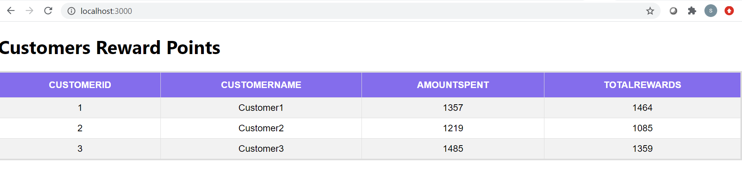

Select a customer to see monthly details

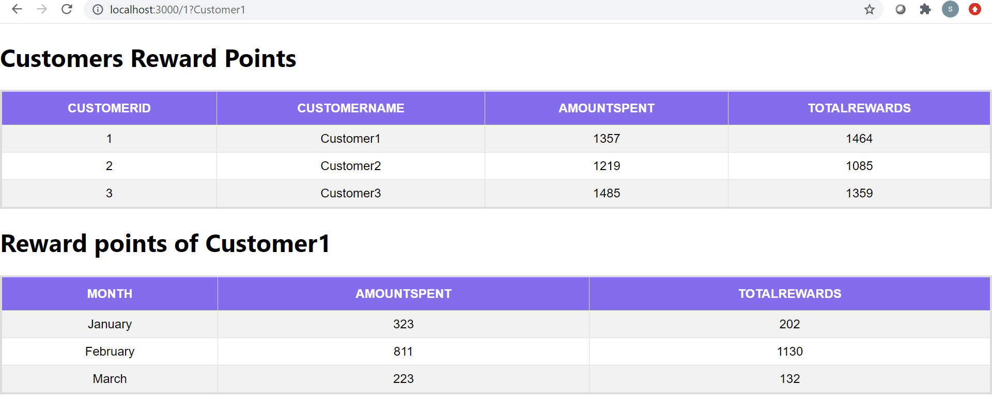

Select a month to see details of customer rewards for selected month

